Tignes in November 98

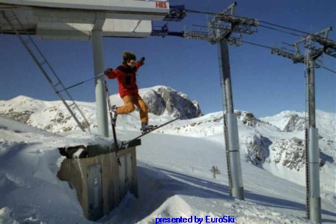

Cem Duru: Uludag, Bursa, Turkey
